Sandra Wendy (Online class)2pm-4pm

Following are the differences between OSI and TCP/IP Model −

| **OSI** | **TCP/IP** |
| --- | --- |
| OSI represents Open System Interconnection. | TCP/IP model represents the Transmission Control Protocol / Internet Protocol. |
| OSI is a generic, protocol independent standard. It is acting as an interaction gateway between the network and the final-user. | TCP/IP model depends on standard protocols about which the computer network has created. It is a connection protocol that assigns the network of hosts over the internet. |
| The OSI model was developed first, and then protocols were created to fit the network architecture’s needs. | The protocols were created first and then built the TCP/IP model. |
| It provides quality services. | It does not provide quality services. |
| The OSI model represents defines administration, interfaces and conventions. It describes clearly which layer provides services. | It does not mention the services, interfaces, and protocols. |
| The protocols of the OSI model are better unseen and can be returned with another appropriate protocol quickly. | The TCP/IP model protocols are not hidden, and we cannot fit a new protocol stack in it. |
| It is difficult as distinguished to TCP/IP. | It is simpler than OSI. |
| It provides both connection and connectionless oriented transmission in the network layer; however, only connection-oriented transmission in the transport layer. | It provides connectionless transmission in the network layer and supports connecting and connectionless-oriented transmission in the transport layer. |
| It uses a horizontal approach. | It uses a vertical approach. |
| The smallest size of the OSI header is 5 bytes. | The smallest size of the TCP/IP header is 20 bytes. |
| Protocols are unknown in the OSI model and are returned while the technology modifies. | In TCP/IP, returning protocol is not difficult. |

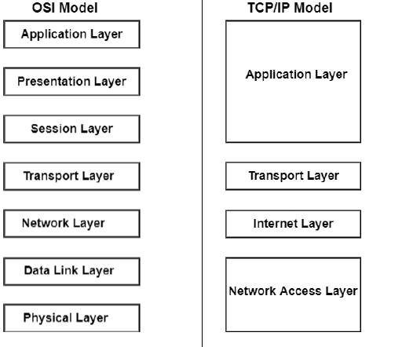

**Layers of the OSI model and their functions:**

**7. Application layer**

It provides protocols that allow software to send and receive information and present it in a meaningful data to users. Uses HTTP, FTP, POP,SMTP and DNS

**6. Presentation layer**

It prepares data for the application layer.

**5. Session layer**

It creates communication channels, sessions, between devices. ensures they remain open while data is being transferred and closing them when communication ends.

**4. Transport layer**

It takes data transferred in the session layer and breaks into segments on the transmitting end and resembles them on the receiving end

**3.Network layer**

It routes packets by discovering the best path across a physical network

**2. Data link layer**

It establishes and terminates a connection between two physically connected nodes on a network.it uses MAC address to connect devices.

**1.Physical layer**

It is responsible for the cable or wireless connection between network nodes.

**Layers of tcp/ip model and their functions:**

* Layer 5,6,7 are combined into one application layer
* Layer 1,2 are combined into one network access layer